Cancer Center Hub Client (CCHC) 1.0

caXchange – ScenPro, Inc.

End User Guide

DOCUMENT CHANGE HISTORY
Version Number | Date | Contributor | Description
1.0 | 2/11/2008 | Michael Holck | Initial Draft
2.0 | 10/11/2010 | Naveen Amiruddin | 2.2 updates


Updated February 11, 2008

Contact Information
Contacts and Support
NCICB Application Support | http://ncicb.nci.nih.gov/NCICB/support  Telephone: 301-451-4384  Toll free: 888-478-4423

LISTSERV Facilities Pertinent to software teams
LISTSERV | URL | Name

TABLE OF CONTENTS
1. Summary 1
2. Introduction 2
2.1 Overview 2
2.2 Dependencies 2
2.3 Security 2
3. Installation Steps 3
3.1 Zip file 3
4. Application Operation Steps 3
4.1 MAIN Window 3
4.1.1 Main page 3
4.1.2 .CSV to HL7V3 Settings. 4
4.1.3 HL7V2 to HL7V3 Settings 5
4.1.4 Common Settings 6
4.1.5 User Credentials Settings 7
4.1.6 Help Action 8
4.1.7 Accept Action 9
4.1.8 Clear Action 10
4.1.9 Close Action 11
4.2 STATUS WINDOW 12
4.2.1 View Status Logs. 12

Summary
The Cancer Center Hub Client (CCHC) is a stand-alone desktop application. It is used to transform the lab data in the form of .CSV files and HL7V2 messages to HL7V3 message format. These HL7V3 messages are saved in the CTODS database using the Grid Services.

CCHC transformation functions include:
- User sets their transformation preferences.
- CCHC performs the transformation service using these user preferences and by invoking caAdapter APIs.
- CCHC invokes the Grid Service to perform study lookup on a participant to pre-populate study information in the HL7V3 message.
- CCHC saves the generated HL7V3 message into the CTODS database.
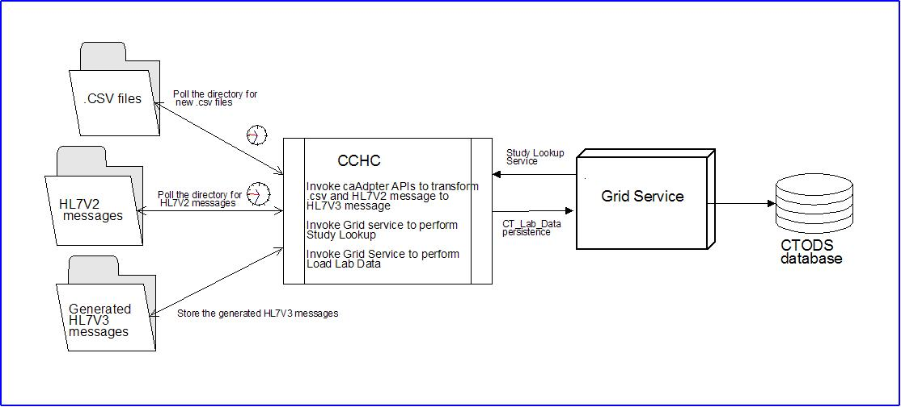
Figure 1Cancer Center Hub Client (CCHC) Message Transformation Process

Introduction

Overview
This user guide identifies and describes the general features and functionality as provided and displayed by CCHC version 1.0. This document has been published to specifically support the use of CCHC.
This document describes the CCHC user interface capabilities and compoenents with screen shots that have been augmented with graphic elements (i.e. boxes, lines, text, etc.). CCHC documentation can be accessed at:
https://gforge.nci.nih.gov/plugins/scmcvs/cvsweb.php/caxchange/?cvsroot=caxchange

Dependencies
The assumptions and dependencies to support the use of CCHC by a user include:
- The CCHC is available for use on an authorized system.
- Current system security protocols are in place and operational.
- The user has access and authorization to use CCHC.

Security
CCHC accesses, displays, and brokers sensitive individually identifiable patient health information. It is the user’s responsibility to ensure that CCHC is used appropriately, to include:
- Exclusively limit the viewing of patient information to authorized personnel only.
- Patient information shall not be released in any form to anyone not directly authorized to view and use the information.
- Patient information will only be searched and displayed for purposes directly related to NCI officially sanctioned tasks and purposes.
- The user shall log out and close the browser at the conclusion of the session.
- The user shall not provide another with their unique user ID and password that is used to access CCHC.

Installation Steps

Zip file
- Create a folder cchc2.2 anywhere in your system
- Extract CAXCHANGEClient.zip to the cchc2.2
- Edit cchc2.2/resources/security-properties.xml
  - Open resources/security-properties.xml in a text or editor
  - Modify <application-name> (line 25) to an appropriate value
  - (eg) <application-name>LabViewer 2.2</application-name>
  - Modify < host-identity> line (26) to an appropriate host identify
  - (eg) <host-identity>/O=caBIG/OU=caGrid/OU=Stage LOA1/OU=Services/CN=ctmssuite.nci.nih.gov</host-identity>
  - Also make sure the < service-url> is pointing correctly
- Create the following folders
  - cchc2.2\poll\csv
  - cchc2.2\poll\hv7v2
  - cchc2.2\poll\hv7v7
  - cchc2.2\fileproccessor\error
  - cchc2.2\fileproccessor\in
  - cchc2.2\fileproccessor\in\error
  - cchc2.2\fileproccessor\in\inprocess
  - cchc2.2\fileproccessor\in\rawFilesBackup
  - cchc2.2\fileproccessor\processed
- Edit property file under cchc2.2\properties\DefaultProperties.properties
Property Name | Value
rawFilesFolder | cchc2.2\poll\csv
HL7V3Dir | cchc2.2\poll\hv7v7
mapFileName | cchc2.2\LAB_DATA\LAB_DATA.map
HL7V2Dir | cchc2.2\poll\hv7v2
hl7v2mapFileName | cchc2.2\v2tov3\v2.map
scsFileName | cchc2.2\v2tov3\v2.scs
inProcessDirectory | cchc2.2\fileproccessor\in
inProcessFolder | cchc2.2\fileproccessor\inprocess
rawFilesBackupFolder | cchc2.2\fileproccessor\in\rawfilesbackup
errorFolder | cchc2.2\fileproccessor\in\error
processedFolder | cchc2.2\fileproccessor\processed
pollingDelayInSeconds | << number of seconds to delay between each pool>  (Eg) 300
initialDelayInSeconds | << number of seconds to delay to start the process>>  (eg) 60
Location | <<Name of the client>>
V2Version | 2.3
ORGANIZATIONNAME | << name of the organization>>
userName | <<user name for Lab Data user>>
userPassword | <<password of the lab Data user>>
authenticationService | <<url of the websso>>
HubURL | <<url of the integration hub>>
StudyLookUpServiceURL | <<url of the study service>>  (Eg) https:serveraddress:port/ctom-wsrf/services/cagrid/StudyService
preProcessorPropertiesFile | cchc2.2\LAB_DATA\ preprocessor.properties

- Sample property would like like
rawFilesFolder=D:/cchc2.2/poll/csv
HL7V3Dir=D:/cchc2.2/poll/hl7v3
mapFileName=D:/cchc2.2/LAB_DATA/LAB_DATA.map
HL7V2Dir=D:/cchc2.2/poll/hl7v2
hl7v2mapFileName=D:/cchc2.2/v2tov3/v2.map
scsFileName=D:/cchc2.2/v2tov3/v2.scs
inProcessDirectory=D:/cchc2.2/fileproccessor/in
inProcessFolder=D:/cchc2.2/fileproccessor/in/inprocess
rawFilesBackupFolder=D:/cchc2.2/fileproccessor/in/rawfilesbackup
errorFolder=D:/cchc2.2/fileproccessor/in/error
processedFolder=D:/cchc2.2/fileproccessor/processed
pollingDelayInSeconds=300
initialDelayInSeconds=60
Location=TrialLocation
V2Version=2.3
ORGANIZATIONNAME=LOMBARDI
userName=xc21@nci
userPassword=D3cc@NC1.org
authenticationService=https://ncias-c278-v.nci.nih.gov:28443/webssoserver
HubURL=https://ncias-c278-v.nci.nih.gov:58445/wsrf-ihub/services/cagrid/CaXchangeRequestProcessor
StudyLookUpServiceURL=https://ncias-c278-v.nci.nih.gov:21443/ctom-wsrf/services/cagrid/StudyService
preProcessorPropertiesFile=D:/cchc2.2/LAB_DATA/preprocessor.properties

Application Operation Steps

MAIN Window

Main page
- Double click on the run.bat file.
- CCHC main page will display
- You should be able to see all the values entered in the property file

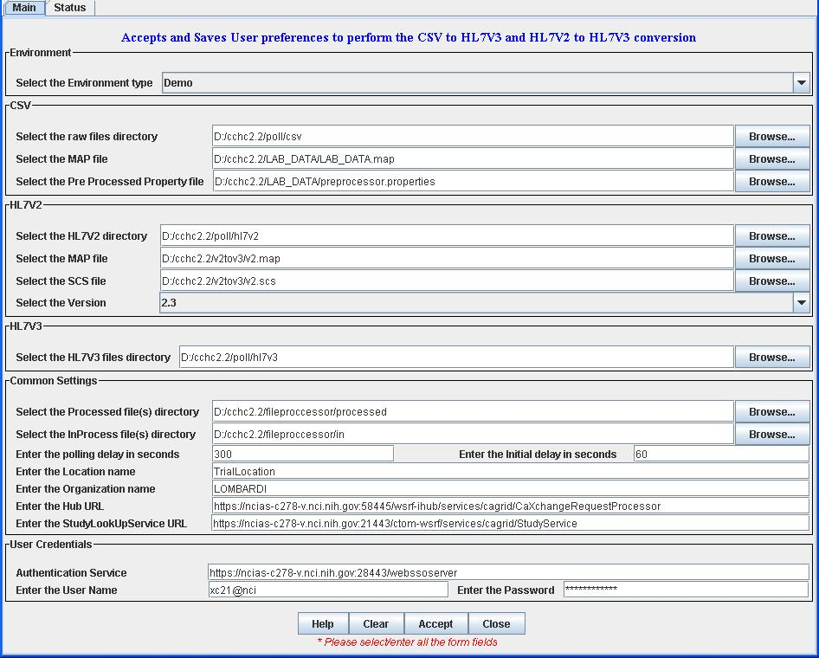
Figure 2 Cancer Center Hub Client (CCHC) Main Page

Help Action
- Selecting/Clicking the Help button will open the CCHC End User Manual.
Figure 7 Access Help

Accept Action
- Selecting/Clicking the Accept Button will save the user preferences into a properties file
Note: The properties file can be accessed and modified in the future. The properties file gets saved in the properties directory under the zip file extracted folder.
Figure 8 Accept Transformation

Clear Action
- Selecting/Clicking the Clear Button will clear all the fields and user settings.
Figure 9 Clear Action Feature

Close Action
- Selecting/Clicking the Close button will close the GUI and stop the process of polling the directories for new .CSV files and HL7V2 files.
Figure 10 Close Application

STATUS WINDOW

View Status Logs.
- Select the Status tab to view status data.
Note: The status screen displays the log messages from the application. The log file is saved under the log directory in the zip file extracted folder.
Figure 11 Status Tab

- The status window displays.
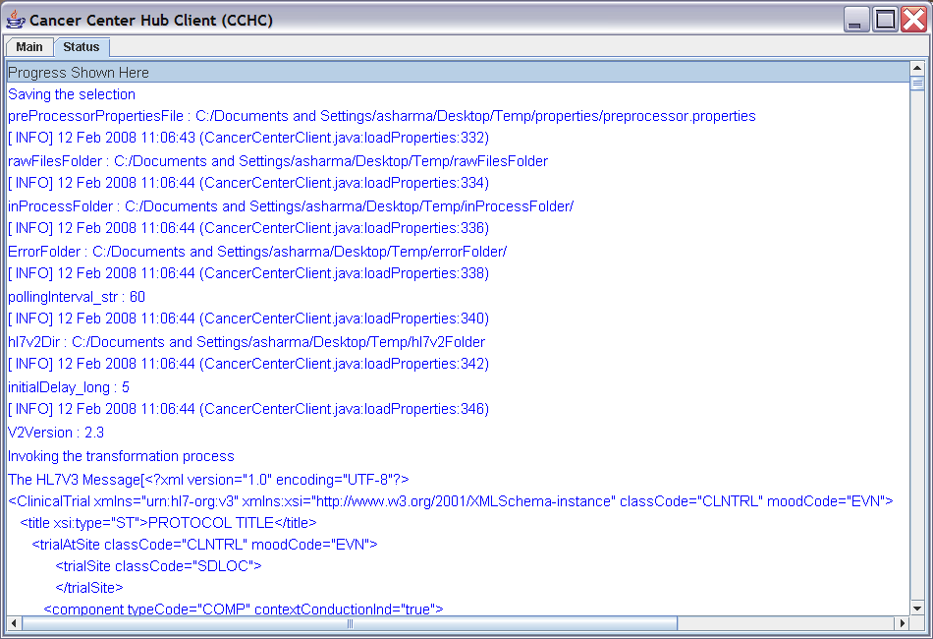
Figure 12 Status Window

